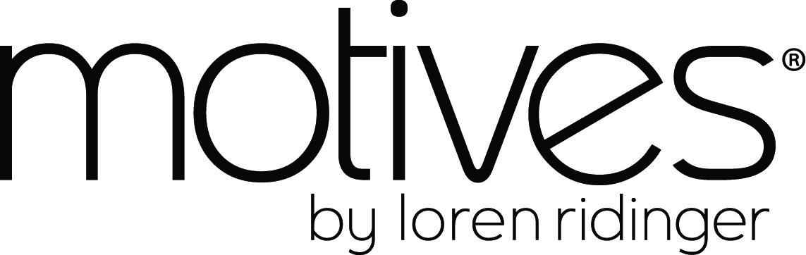

Building Your Business with Motives®

AGENDA:
- Teaches why gaining knowledge and building confidence…
- Showcases why approaching the business with the right mindset and attitude…
- Illustrates why creating a sense of purpose and setting goals…
- Explains why developing a plan of action…
- Demonstrates why expanding distribution to earn a six-figure annual income…
- Instructs why building your teams through leverage and duplication…
… is critical to success!

MOTIVES® by Loren Ridinger
High-quality, competitively-priced products
  - Quality tested products that deliver what they promise
  - Color choices that cater to all skin tones
Many options for the consumer
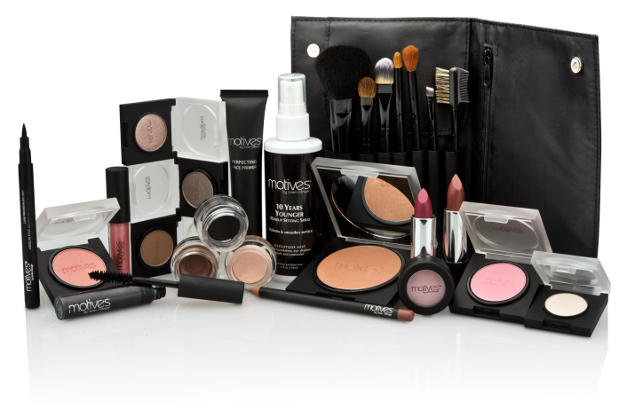
    - Experience the products hands-on before purchasing
    - Customized cosmetics
Individually-tailored consultations
    - One-on-one attention
    - Personal service

Turn your love of makeup into making money!

Two ways to earn income as a Motives Beauty Advisor:

Individual Sales
Earn 30% or more in retail profits from your sales
Earn $300 or more per Beauty event*
Market and promote through your personal
MotivesCosmetics.com website

Team Sales
Build two teams of Beauty Advisors, each generating 5,000 BV
per week to earn $1,500 or more in commissions weekly
Build additional teams and/or host more Beauty events and commissions increase exponentially

*Average Beauty event generates sales of $1,000 or more per event

MOTIVES® BY LOREN RIDINGER
We offer your business:

- Top of the line cosmetics with affordable pricing
- Customized Color Cosmetics
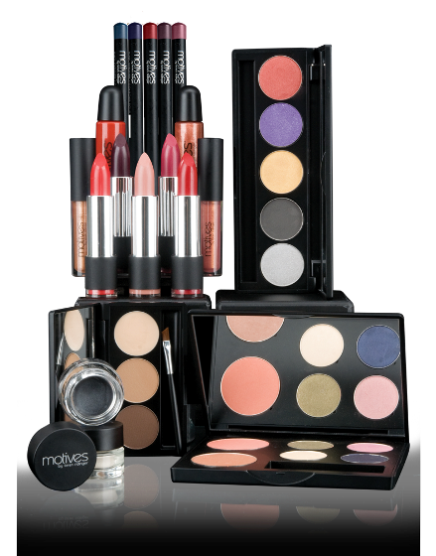
- Proprietary Formulas
- Cosmetics for Every Skin Tone
- Hypoallergenic and
non-comedogenic formulas
- Training Program
- Motives ProArtist Program
- Motives & Me: Teen Program
- MotivesCosmetics.com

Motives® Business Building Tools
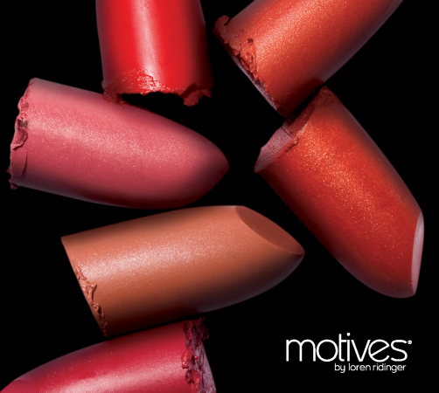
- Motives Catalogs
Code: 3517 DC: $10.00
- Skin Care Catalog
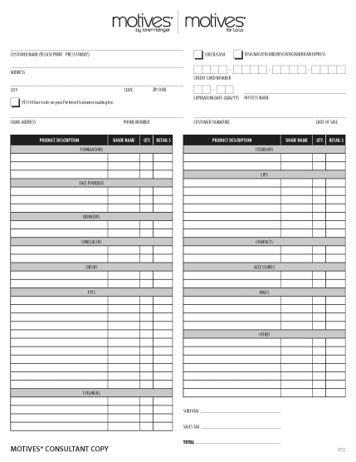
Code: SC3517 DC: $10.00
- Order Forms
Code: 100 DC: $4.00
- Motives Folders
Code:138 DC: $6.00
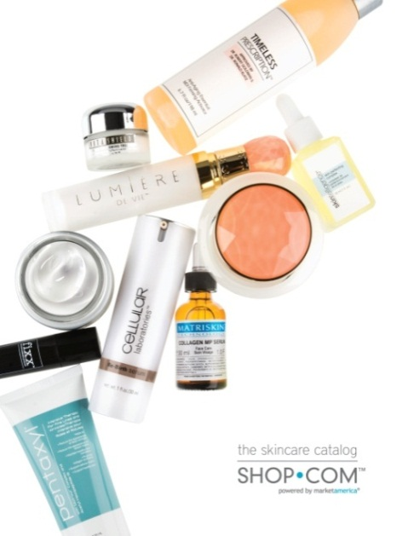
- MA® Print Center
  - Invitational Postcards
  - Motives Business Cards

Attitude for Success
- Your attitude is the little difference that makes a BIG difference
- It is not the challenges we face, but how we respond to them
- Positive, “can-do” attitude is the key to self-motivation
- It allows us to choose:
  - Action over apathy
  - Courage over fear
  - Growth over stagnation

- Whatever you choose to give energy to grows…
It is a choice… YOUR choice!
- You can give energy to negative things or positive
things… Both will grow!

What Are You Afraid Of?
- Fear of Failure
  - Only through failure do we learn. We get smarter, tougher and we take what we learned and press on
  - There are no consequences for failure in Market America – you simply start again, wiser for the experience
  - Fear of Rejection
  - No one is saying “no” to you:
    - Saying “know”: I need to know more information
    - Saying “no”: It’s not the right time

Never place higher value on someone else’s opinion
of you, than you place on your own

The best way to combat your fear is…
Your Reason “Why”
- Why did you start your Motives® business?
- Why do you need more money?
- Why do you need more time?

Name: ___________________________________ Date:______________

Building your Business with Motives

- What is Motives?

_______________________________________________________________________________

_______________________________________________________________________________
_______________________________________________________________________________

- What Do you Do?

_______________________________________________________________________________
_______________________________________________________________________________
_______________________________________________________________________________
_______________________________________________________________________________
_______________________________________________________________________________
_______________________________________________________________________________

- Write Your “Why”-

_______________________________________________________________________________

_______________________________________________________________________________

_______________________________________________________________________________

_______________________________________________________________________________
_______________________________________________________________________________
_______________________________________________________________________________

Goals
Why you need goals?
- Each of us are unique, it is important to think hard about:
  - Who you are
  - Who you want to be
  - What qualities you want to develop
  - What lifestyle you want to live
  - What results you want to achieve
- These decisions affect the changes you make and the way you will spend your time!
Ask yourself-
  - What do I REALLY want?
  - When do I REALLY want it?
  - What am I REALLY willing to overcome?
  - What is REALLY realistic based on my available time and commitment?
Your goals need to be S.M.A.R.T.:
  - Specific
  - Measurable
  - Attainable
  - Realistic
  - Timely

Attaining your Goals
- List goals in order of attainability
- Determine the income necessary to support your lifestyle and goals
- Set target dates for achievement
- Measure your progress against the date
- Adjust the date or goal to be in line with reality

Example:
“Today is March 31, 2014 and I am so happy and
grateful that I became a Motives® Beauty Advisor. I’ve
been retailing $1,000 per month. I’ve also created two
teams of Beauty Advisors, that are duplicating the same
in retail sales each month. I am making enough to lease
a new Mercedes; have created $1,500 / month in
additional income and quit my second job; and have
paid off $3,000 in credit card debt, through my Motives
business.”

Write “What You Want” – the tangible items you want that make your “WHY” real.
Example:
What You Want | When You Want It | How Much Does it Cost
Lease New Car | ≤ 12 months | $600/ month
Pay Off Credit Card | ≤ 6 months | $3,000
Replace Income | ≤ 12 months | $1,500/ month

What You Want | When You Want It | How Much Does it Cost

Assumptions for Creating a Plan of Action

- Earn 30% retail profit on sale of Motives® Cosmetics
- Create $1,000 retail sales of Motives Cosmetics = $300 or more in profit
- Generate $1,000 retail sales of Motives Cosmetics = 500 BV or more
- Know that 50% or more clients will buy again monthly (based on add-on sales of cosmetics, skincare and health and nutrition supplements)
- Two (2) teams of Beauty Advisors/ UnFranchise Owners each generating 5,000 BV results in $1,500 in commissions

Goal Setting
S.M.A.R.T. assessment

$600 / Month Car Payment
Your Individual Efforts
- Conduct one (1) Beauty Event / month
  - $1,000 retail sales / event ≈ $300 profit
  - $1,000 retail sales / event ≈ 500 BV MPCP
Your Results
- After 12 months (assuming 50% new sales / event AND 50% re-purchase / month)
  - 50% of $12,000 ≈ $6,000 (new business) for 12 months
  - 50% of $6,000 ≈ $3,000 (re-purchase) / month
  - $3,000 / month ≈ 1,500 BV ≈ $300 commissions / eight weeks
- Created ≈ $1,000 / month income
  - $900 / month retail profit
  - $150 / month commissions

Assumptions for Team building Plan of Action

- 30% retail profit on sale of Motives Cosmetics
- $1,000 retail sales of Motives® Cosmetics = $300 or more in profit
- Average retail sales per Beauty Event ≈ $1,000
- $1,000 retail sales of Motives Cosmetics = 500 BV or more
- Two (2) teams of Beauty Advisors / UnFranchise Owners each generating 5,000 BV results in $1,500 in commissions
- 50% or more clients will buy again monthly (based on add-on sales of cosmetics, skincare and health and nutrition supplements)
- Each Beauty Advisor (Team Member) commits to selling $1,000 at retail / month ($500 / month new business)
- Each Beauty Advisor (Team Member) commits to exposing the Business Plan to four (4) qualified individuals per month
- Registration ratio of 8:1
  - Expose Business Plan to eight qualified individuals
  - Register one (1) new Beauty Advisor

Assumptions for Team Building Plan of Action

Team Growth Based on 8:1 Ratio
L
E
F
T
- Month 1 = You + 1 (8 qualified individuals)
- Month 2 = You + 2 (12 qualified individuals)
- Month 3 = You + 3 (16 qualified individuals)
- Month 4 = You + 5 (20 qualified individuals)
R
I
G
H
T
- Month 5 = You + 1 (8 qualified individuals)
- Month 6 = You + 2 (12 qualified individuals)
- Month 7 = You + 3 (16 qualified individuals)
- Month 8 = You + 5 (20 qualified individuals)

Rhythm of the Business- Schedule
Monday –
  - Trainings
  - Coring on special topics with team
  - Make calls
  - Call workshop- You want to do this with your team if possible, you should have call workshops running in your organization in different areas simultaneously
- Engage in dialogue with people and add to your possibilities list

Tuesday-
  - Motives® Business Presentation
  - Motives Presentation in the Home (MHBP)
  - One-on-Ones, Two-on-Ones
  - Anything that has to do with business building
- Engage in dialogue with people and add to your possibilities list

Thursday-
- Completely Dedicated to Products
  - Not doing make-overs
  - Decide on 5 to 10 key products, demonstrate a few
  - This is a 10 new Customer Night, Register New Customers, Get Orders

- Host a Motives® Event
  - Motives Beauty Basics
  - All About Skin Event
  - Blend your Beauty Event

Your Plan of Action Summary
Required Activities and Numbers
You
- Retail $1,000 / month ($500 new business) for 12 months
- Create 500 BV / month from retail sales
- Expose the Business Plan to four qualified individuals / month
- Register one New Business Partner every two (2) months
- Implement all scheduled activities weekly

Business Partners (Team Members)
- Retail $1,000 / month ($500 new business) for 12 months
- Create 500 BV / month from retail sales
- Expose the Business Plan to four qualified individuals / month
- Register one New Business Partner every two (2) months
- Implement all scheduled activities weekly

Keys to Retailing:
- Obtain knowledge about your product. Keep it simple pick 10 products and learn key benefits and features about them
  - Remember:
    - Benefits – Sell
    - Features – Tell
    - Refer to Motives Product Knowledge, Application and Sales Training
- Build relationships to increase sales
  - Ask open-ended questions
  - Start a dialogue
  - Learn about your customers
  - Conduct events to expose more people to our amazing products
- Always give out a Motives® Catalog and Skincare Catalog with a purchase

Words that Sell
- Use key words that will attract, entice and excite customers to buy your products
- Words can have a positive or negative influence on people
Example: Would you rather have a solution or a proven
solution? Do you see the difference?
- The language you use to describe products can increase your retail sales

- Advanced
- Solution-oriented
- Results-oriented
- Proven results
- Best-selling
- Top-selling
- Improved
- Highest quality
- Limited
- Latest
- Greatest
- Convenient
- Unique
- Cutting-edge
- Revolutionary
- Effective
- Incredible results
- Increased effectiveness
- Professional
- Breakthrough
- New
- Must-haves
- Cant live without
- Best

Motives® Add-on Sales

For customers that buy Eye Shadow, recommend:
Eye Base
    - Helps eye shadow adhere and stay in place all day
    - Eliminates eye shadow creasing
    - Helps intensify the color of the shadow
Invisi-Line
    - Minimizes the appearance of lines and wrinkles around the eyes
    - Delivers a highlighting effect which brightens up the eyes
Eye Lash Curler
    - Helps to curl and lift the lashes to help eyes look bigger and more open

For customers that buy Lipstick, recommend:
Lip Crayon
    - Lines and fills in lips to help lip color last longer

Skin Care Add-On Sales
Skincare products to recommend to every client:
- Fixx Microdermabrasion-
  - Gently exfoliates surface skin cells
  - Helps your moisturizer penetrate more effectively
  - Allows your makeup to glide on more smoothly
- VitaShield Intensive Eye Firming Treatment-
  - Powerful antioxidant
  - Delivers moisture to the delicate skin underneath the eyes
  - Firms and combats lines and wrinkles
- Pentaxyl-
  - Formulated with advanced anti-aging ingredients
  - Reduces the appearance of lines and wrinkles
  - Helps skin look brighter and delivers a youthful glow
- Fixx Stem Cell Serum-
  - Helps support skin’s collagen and elastin production, keeping skin firm
  - Reduces the appearance of lines and wrinkles
- Delivers hydration for a more youthful look

Events Create Leverage
- Expose the products to a greater number of people at one time
- Capitalize on energy and enthusiasm of the attendees!

Five Keys to a Successful Event
- Have a motivated host/hostess
- Ensuring great attendance
- Event preparation/set-up/execution
- Close the sale
- Book future events and follow-up

Host a Motives® Event
And Earn Free Product or Cash!!!

There are a variety of Motives Events you can host here are just a few:

- Motives Trunk Show: See the latest trends in cosmetics; skin care and fashion all come together. Learn tips and tricks celebrities use to look their best!

- Motives Custom Blend Expo: Have your perfect match made with Motives Custom Blend products – both liquid and powder formulas - for foundations, skincare, powders and more to transform your look and skin into something extraordinary.

- Motives Press Expo: Look who’s talking about Motives in the Beauty and Fashion Industry. Join us and see how the award winning Motives cosmetics line can recreate the latest celebrity trends and looks for you and your friends at affordable prices.

There are lots of reasons to Host a Motives Event besides good times with friends you can also earn free products and/or cash. Choose from one of the following ways to earn:

Motives Events: Hostess will receive the discount program and an exclusive hostess only gift based on sales.
Personal Purchase | Event Sales Total
20% | $500 - $1000
20% | $1001 - $1500
20% | $1501 - $2000

Hostess Custom Blend Expo Incentive: Hostess will receive the Incentive Bonus and a Free Custom Blend
Cash Per Bottle | Custom Blends Sold at the Event | Hostess Rewards Example
$5 per Bottle | 1-10 | $5 x 10 = $50
$10 per Bottle | 11-20 | $10 x 20 = $200

Exclusive Offers
Your Motives Consultant always has special offers to share with their Hostess, so be sure to ask them.

Contact Your Motives Consultant Today!
Sample Script:
Hi _________. Are you doing anything next Thursday? Well, I came across this amazing cosmetic line that is the quality of Chanel but half the price.
I am hosting a Beauty 101 Event at my home. I know you like make up, looking great and saving money just like me. It is only a hour or so and it would mean a lot to me if you would come and we will have some fun. Are you available?

Creating your Possibilities List
- Your Possibilities List must contain 60-300 names
  - It becomes your immediate inventory for potential Clients, Hosts/Hostesses, Business Partners, etc.
  - These connections also provide you with potential new networks to penetrate
  - It gives you posture when you enter into dialogue and conversation

Possibilities Are Everywhere
- Your contact list from your cell phone and email
- Your address book
- Your social networks
- Organizations you belong to
- Directories – church, high school, college
- People you meet every time you run errands
- People you meet through networking events
- People you meet who wear makeup
- People you meet every time something breaks
- People you meet when you buy something
- People you meet through your kids’ school and
activities

Preparing for Approaching your Possibilities
Topics of Conversation:
- Top-of-the-line cosmetics with affordable pricing
- Customized color cosmetics
- Beauty in every shade
- Time freedom
- Being your own boss
- Making people beautiful makes money
- Proprietary formulas
- Training programs
- Motives Pro Artist Program
- Motives and Me: Teen Program
What Do You Do?
Developing Your Answer
- The focus of your conversation should be why you are building and expanding your UnFranchise business on the side
- You can mention what you do for a full-time career/job, but the primary emphasis of the conversation must be your Motives®/Market America business

- Your answer should:
  - Generate interest
  - Have an appealing description of what you do

- Have a benefit-
  - Don’t have to be a makeup artist to sell Motives
  - Work from home
  - Work part time to potentially earn a full time income
  - Consumable products, customers will need to re-order

What Do You Do?
Example Script:
- I work with an award-winning makeup line
- I work with Custom Blend cosmetics
  - Then expand with two minute commercial
- I have always dreamed of a career in the fashion or beauty industry. I thought about makeup or cosmetology school, but was worried about the time and money investment.
- I work with an amazing makeup line, Motives® Cosmetics, which gives me the training necessary on building a business for myself without quitting what I was currently doing.

Before You Approach, Remember:
- Prospecting for Clients/Business Partners is a process, not an event
- Pick a theme that is relevant to the person you’re approaching and stick to it
- Talk less, listen more
- Be a problem-solver
- Your goal is to demonstrate:
  - The quality of the product
  - The market-appeal of the product
  - The potential for the business
- Communicate the potential for the business if conversation develops in that direction

Sample approaches for a client:
- “If I could show you a way to _______, would you give me 20 minutes?”
- Someone who loves makeup:
  - “You clearly love makeup too much NOT to take a look at this line.”
- Someone who has a skin challenge:
  - “Have you ever considered a customized foundation?”

Sample Approaches for a Business Partner:

- “If I could show you a way to create an additional $1,000 per month helping people look and feel beautiful, would you give me 20 minutes?”
- “If I could show you a way to generate an extra $1,000 per month doing what you’re already doing right now, would you give me 20 minutes?”

Sample call script:

Hi _____________. This is _____________.

I got your number from ____________.
I just came across this amazing, award-winning cosmetic line and immediately thought of you.
The line is Motives® Cosmetics and I was hoping you could help me out by taking a look at it with me and telling me what you think about it.
When can we get together?

Follow up: Creating Leverage through Duplication

The objective of Following-Up:
- Every point of contact with:
  - Client or prospective client
  - Host or prospective host
  - Business Partner or prospective Business Partner

…should result in another contact…
- Each subsequent contact should result in:
  - Another appointment to provide more information
  - A sale
  - Another sale
  - Another event
  - A third-party evaluation of the business
  - Business registration

Following Up with Your Clients:

- Establish a follow-up system
  - Day One - To thank for patronage and inquire about how they are using/enjoying it
  - Day Three – To be sure product is being used properly
  - Day Seven – Share testimonial
  - Day 21 – Take re-order and get referrals

- Build share of clients through add-on product sales
  - Take time to teach every client about how to find, navigate, and shop the MotivesCosmetics.com and SHOP.com sites
  - Ask satisfied customers/clients if they know of people that would have an interest in these products
Every Prospective Business Partner should…
- Visit your MotivesCosmetics.com website
  - Register as a Preferred Customer
  - Take the Skincare Analysis
- Review a copy of the Motives® Press Kit
- Review a copy of the Motives by Loren Ridinger sizzle reel
- Review a copy of the Motives for La La sizzle reel

Video options to send to prospects:

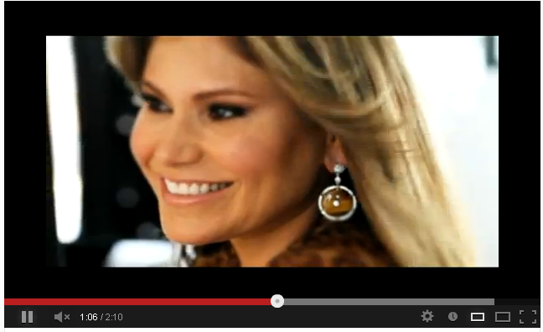

http://www.youtube.com/watch?v=ZBeohm4R00E MOTIVES LaLa Shoot
http://www.youtube.com/watch?v=mML21cjZo-8 Roberto Cavalli at Funkshionswim week 2010 with Motives Cosmetics
http://www.youtube.com/watch?v=Wx_yOMy39FQ -- Motives 4 LaLa E! NEWS
http://www.youtube.com/watch?v=3cN-ZjJu43U -Behind the scenes workshop w/ celeb makeup artist Mario Dedivanovic (Kim Kardashians MUA).
http://www.youtube.com/watch?v=tHVtyGTuQmI -- Motives For La La - Deco Drive
http://www.youtube.com/watch?v=at6M7yH_X0I --CNNE NotiMujer
http://www.youtube.com/watch?v=jfy2u-tESvI&feature=related --MOTIVES Product Demo
http://www.youtube.com/watch?v=S49X3CmqW_E&feature=youtu.be WHY MOTIVES? Business intro

Ideas for Next Steps:
- Have them experience “playing” with the line
- Schedule a time to do their Custom Blend foundation
- Have them host an event or get a few friends together to “play” with the line
- Invite them to a Motives® training
- Show them the Business Plan one-on-one
- Sell them something to wear/try for a few days

You Must Lead by Example:
- Schedule one event per month with your personally-invited guests
- Invite Distributors on your team that also want to generate $1,000 in retail sales per event, so they can learn by assisting you
- Assist your team members with their events until they can lead them on their own

Build a Team of Eight That Duplicates…

- Hosting one event per month that generates:
  - $1,000 in retail sales
  - $300 in retail profit
  - 500 BV
  - At that event:
  - Find a host for another event
  - Find two potential Business Partners
  - Each month, share the business with four qualified people

- Each month, generate 500 BV (250 BV – new) worth of new business for the first 12 months

Building Your Business with Motives®

DATE (mandatory): __ _________LOCATION (mandatory):______________________
TRAINER’S NAME (mandatory):______________________________
Ratings: Please rate your training experience on a scale of 1 - 10
The Trainer was knowledgeable about Motives Business Building fundamentals.
The Trainer demonstrated a thorough knowledge of Motives by Loren Ridinger.
The Trainer was able to explain the tools available to build your Motives business.
The Trainer was able to demonstrate and teach the importance of having a goal statement and steps to achieve it.
The Trainer was able to explain the different retail strategies, and how to conduct an event.
The Trainer was properly dressed and well represented Motives by Loren Ridinger.
The Trainer was able to answer all questions by the end of the class.
The Trainer was able to communicate well; and easily interacted with the class.
The Trainer was able to explain how to build a strong Motives business.
10 = excellent / 7-9 = good/great / 4-6 = average / 1-3 = below average/poor

How many students were in attendance? ___________
How many assistants did the Trainer/Trainers have? ______
What did you like most about the class? ___________________________________________________________________________________________________________________________________________________________________________________________________________________________
Suggestions to improve the trainer’s presentation skills: _________________________________________________________________________
_________________________________________________________________________

Do you feel confident to go out and practice the skills you were taught and grow your Motives business? _____

Optional: ____________________________  NAME | _________________________________  ID NUMBER

Please Return To: Market America Inc.
Motives Department
1302 Pleasant Ridge Rd
Greensboro, NC 27409

